**Task 7**

PERFORMING OPERATIONS LIKE ALTER, UPDATE AND DEL IN VIEW

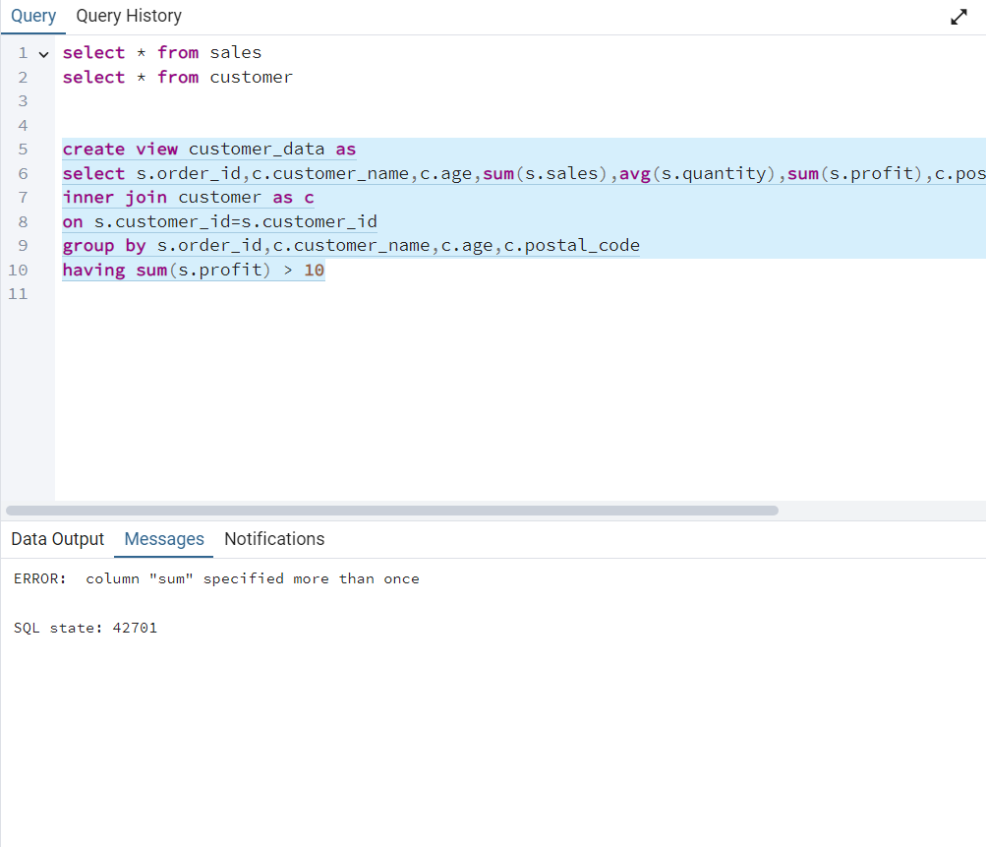1.found error while creating a view table showing “sum” specified more than once

2.view table is successfully created after changing “sum(s.sales)” to “min(s.sales)

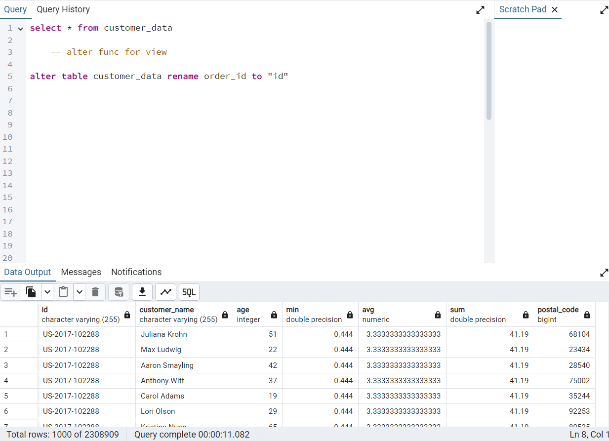3. successfully run alter rename func for column

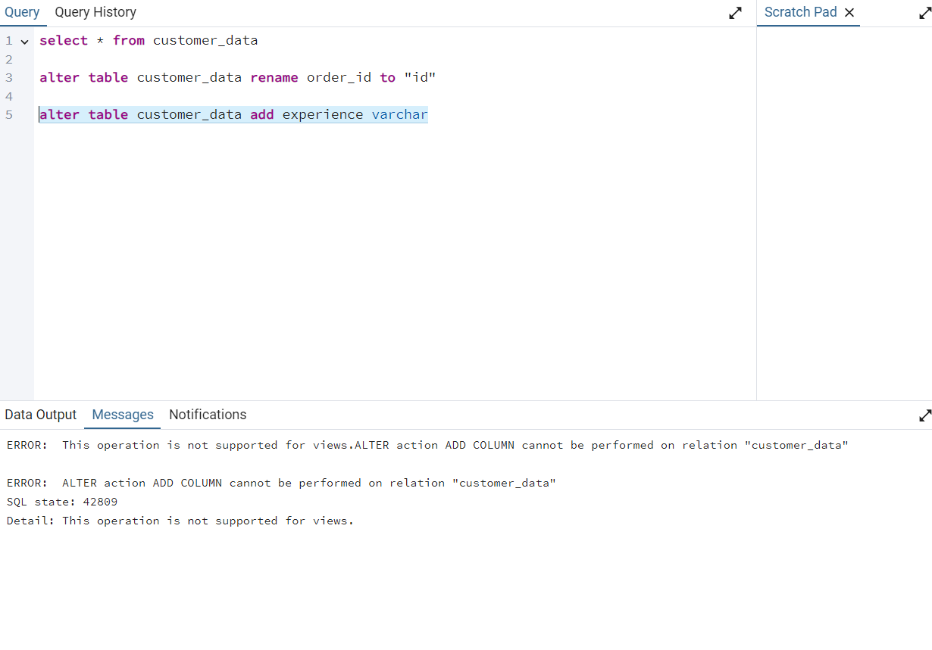4.error while adding a column using alter

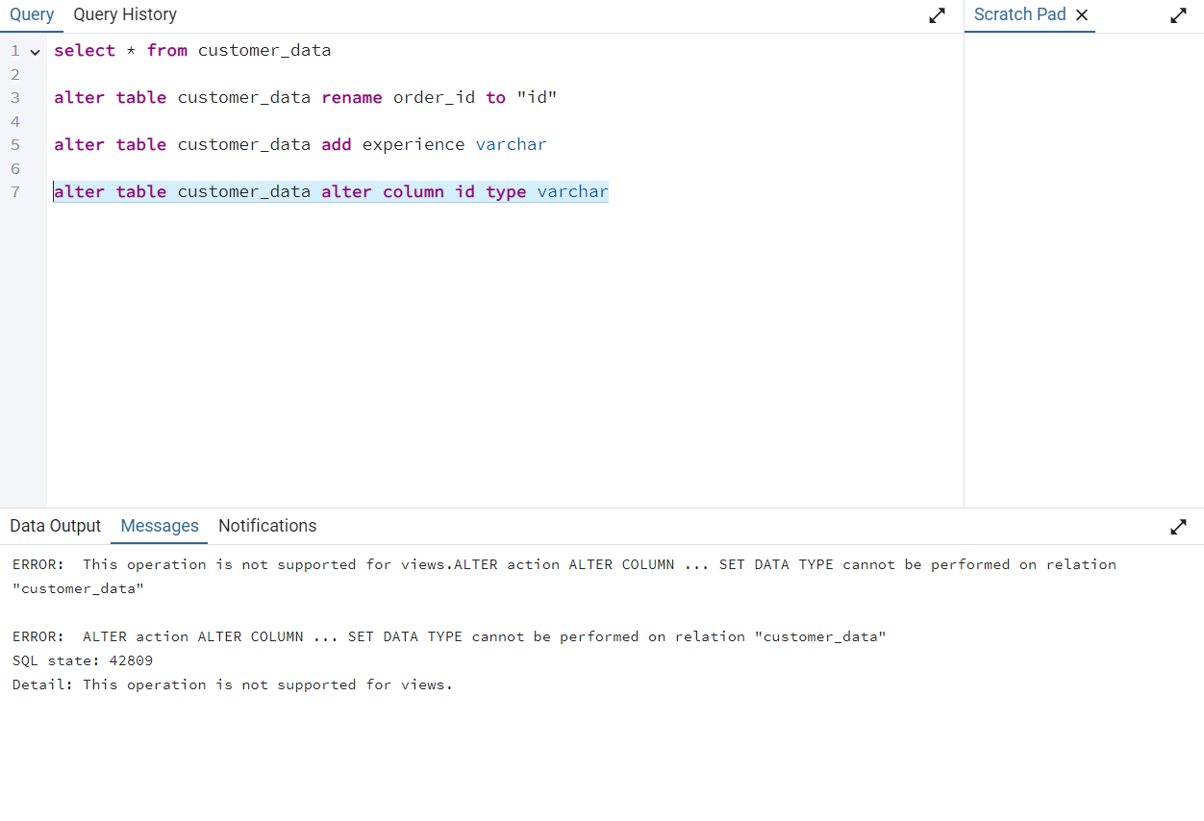5.couldn’t change the type of column

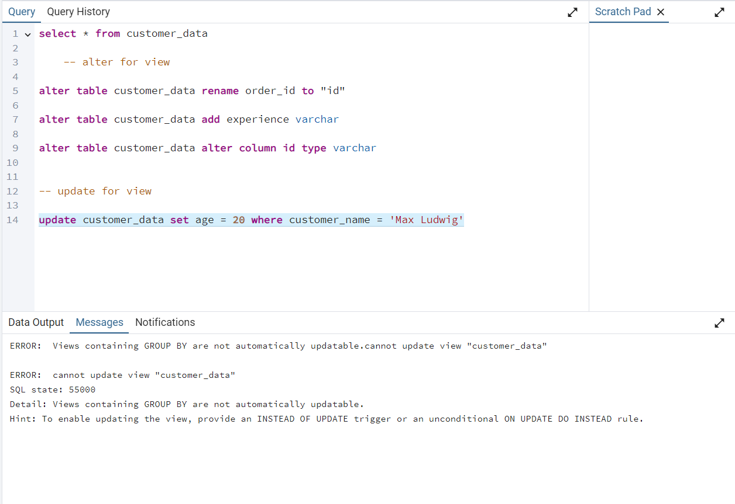6.could not update the rows values using update func

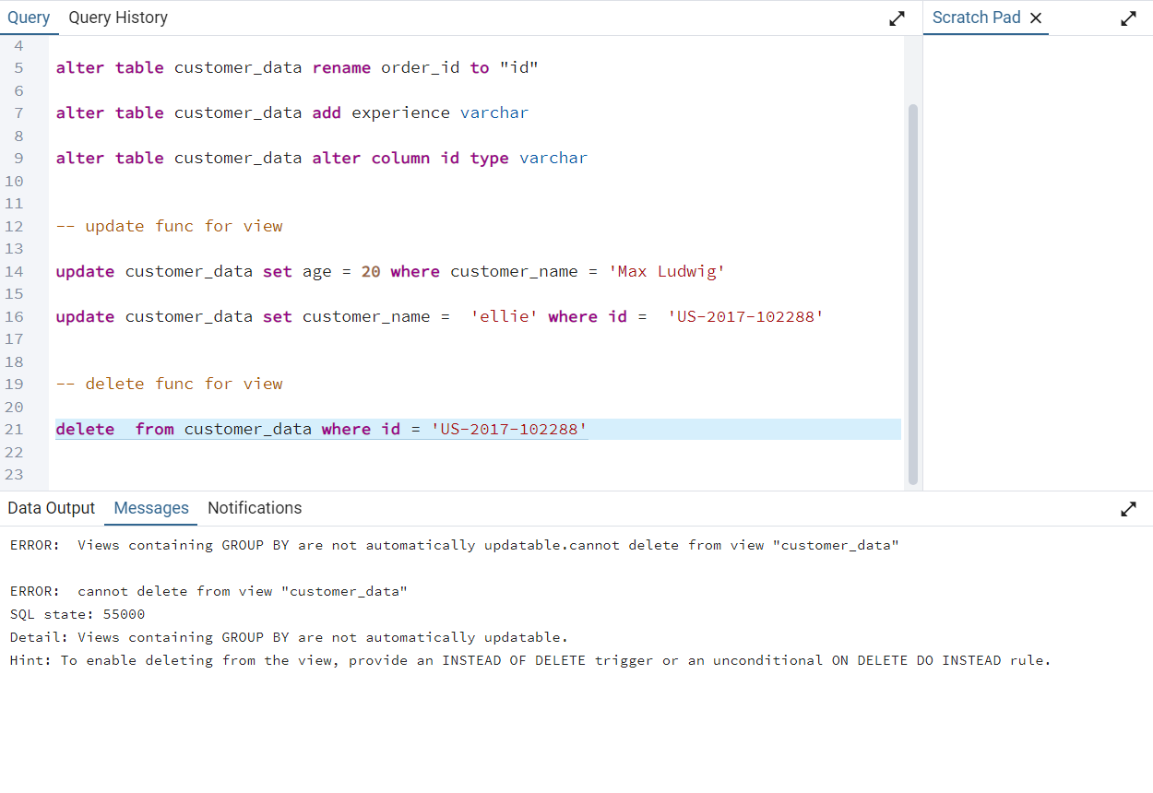7.delete func cannot be use in view table

Conclusion:- only alter rename func was run while performing this task and as we can see in the output it is shown that the “GROUP BY func cant be updatable “